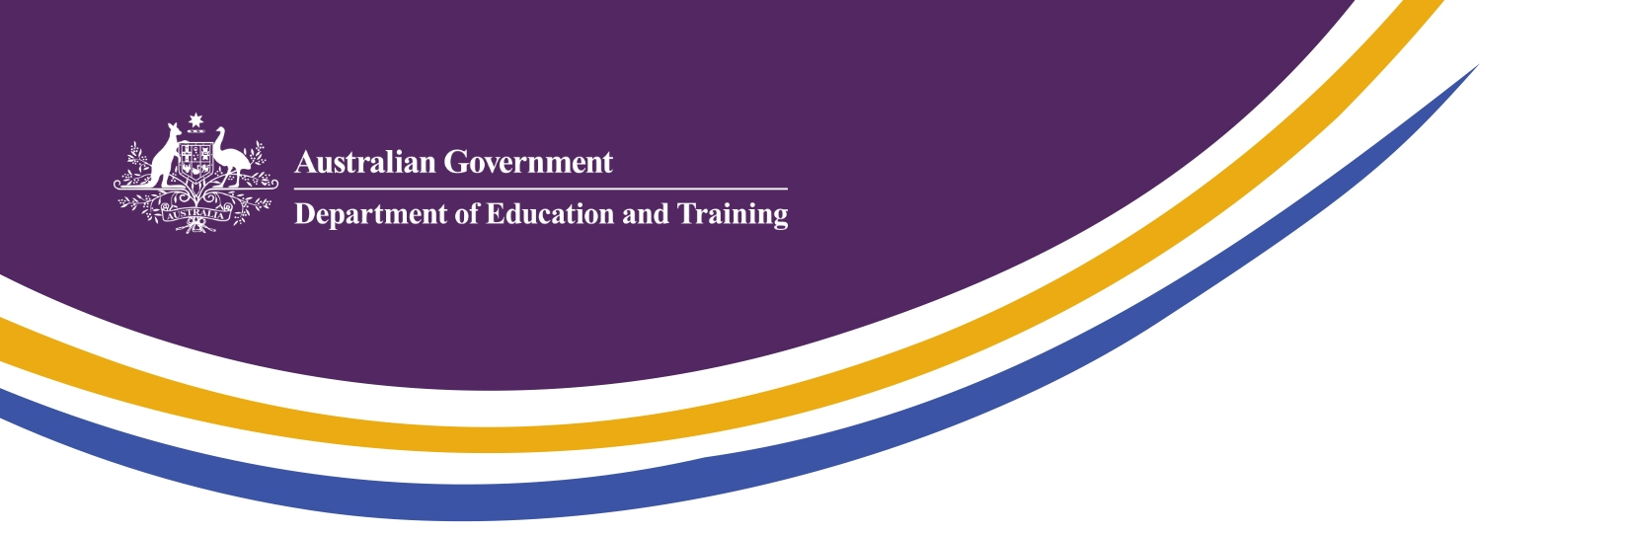

Korea – Australia Education & Research
Quick Facts
- Australia and Korea share a proud history of high quality collaboration in education and research – and this cooperation is getting stronger with biannual joint committee meetings held between both governments since 2008.

- Korea is Australia’s 3rd largest source country for international students with over 30,000 enrolments in 2016. More than half are studying in the vocational education and training sector, which has seen strong growth since 2012.

- Australia is the 2nd most popular English-speaking country, after the US, for Korean students to study abroad in the higher education sector including language training.

- The number of students studying Korean in Australia has been increasing gradually. Currently over 10,000 students study Korean as a foreign language in Australian schools and universities.

- Australia is a popular sister school partner for Korea with approximately 200 school to school arrangements. One of the popular forms of engagement between schools is live video conferencing.

- Australian Universities reported almost 300 formal university partnership agreements between Australian and Korean institutions.

- Since the commencement of the NCP in Korea in 2015, there has been a significant increase in the number of Australian university students coming to Korea. By the end of 2017, almost 550 students will have been supported to study in Korea, with a 65% increase in student numbers between 2016 and 2017.

- Korea is an important science and innovation leader globally, with the fifth highest total investment in R&D in the world. (As a proportion of GDP, Korea’s investment in R&D is second only to Israel, according to the latest OECD data.) More than 75% of Korean R&D is funded by industry, a world-leading level.

- Korea is one of Australia’s priority countries for science and innovation collaboration and Australia is one of the top 10 collaboration countries for Korea.

